INTEGRATED AMPLIFIER CIRCUITS
Objective:
- To observe the behaviours of Darlington Pair, Feedback Pair, Current Mirror and Widlar Current Source Circuits.
- To understand integrated amplifier circuits (OpAmp, etc.) with a combination of the circuits mentioned above.
Theory:
A review of the circuits:
Current Mirror Circuit: Widlar Current Source Circuit:
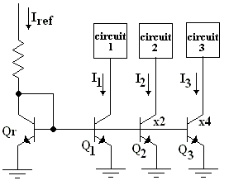
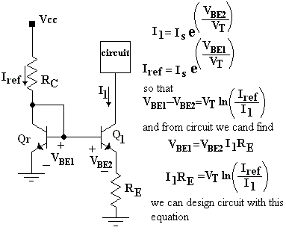
Figure 1
x2, x4 means that Qr and Q₁ have same β, Q₂ has 2β, Q₃ has 4β, so that the current mirror circuit presents I₁=I_{ref},
I₂=2I_{ref}, I₃=4I_{ref} for the circuits,1,2,3 respectively. Figure 2

Darlington Pair Circuit: Feedback Pair Circuit:
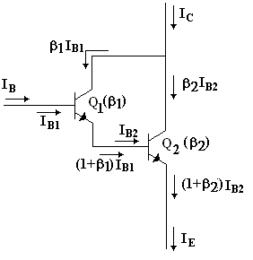
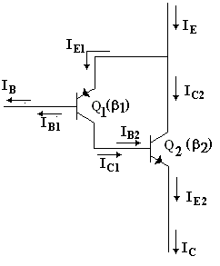

Figure 3
Figure 4

In Figure 3 I_{B2}=(1+β₁)I_{B1} , I_{B}=I_{B1} and I_{C} = β₁I_{B1}+β₂I_{B2} ≈ I_{E} and we find an equivalent transistor called as Darlington Pair with β≈β₁β₂ . If it is use in emitter-follower type circuits, it may behave like an amplifier with infinite input resistance and extremely low output resistance and very high small signal gain.

In Figure 4 I_{E2}=(1+β₂)I_{B2} , I_{C1}=β₁I_{B1} , I_{B}=I_{B1} and I_{E} = I_{E1}+I_{C2} , I_{E1}=I_{C1} and we find an equivalent transistor called as Feedback Pair with β≈β₁β₂ .

Preliminary Work:

A typical integrated amplifier circuit is shown in Figure 5. Find all voltage values (Va,Vb,Vc,Vd) at indicated nodes and currents (Ia,Ib,Ic,Id,Ie,If,Ig,Ih,Ik) on the indicated arms for V_{in1}=0V, V_{in2}=0V, V_{up}=+15V and V_{down}= –15V GND=0V, Vo indicates amplified signal output... All Q transistors have β, but T transistor have 4β.
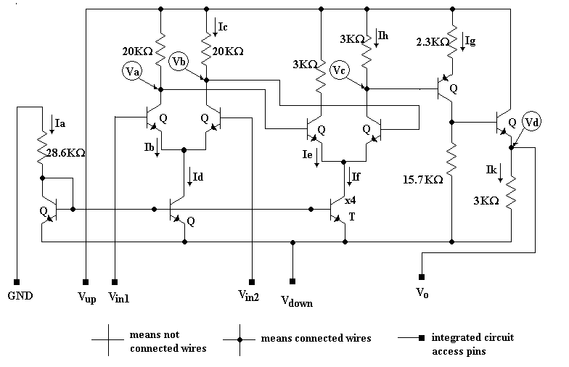

Figure 5

Procedure:

- To demonstrate the use of a BJT as a current source, connect the circuit in Figure 6
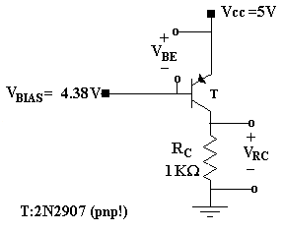
Figure 6

- After adjusting V_{BIAS} to 4.38 V –approximately- (we need to bias the BJT), measure and record V_{BE} and V_{RC} in Figure 6. Wait until transistor stabilizes!
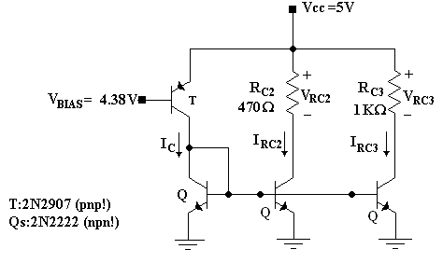
Figure 7

- Now replace the 1 KΩ resistor in Figure 6 with the current mirror circuit in Figure 7.All Qs are identical.

- Measure and record the voltages V_{RC2} and V_{RC3} .Then use them to calculate the currents I_{C2},I_{C3} for question 2. Measure and record the currents I_{C2},I_{C3}.

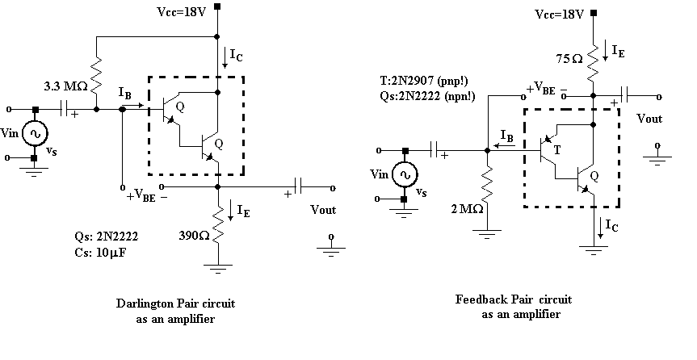
- To demonstrate the behaviour of Darlington and Feedback Pairs construct the circuits in Figure 8.
Figure 8

- Measure and record the V_{BE(Darlington)} , V_{BE(Feedback)} and measure and calculate the equivalent β of two circuits. And give the input signal Vs(t)=50sin(10000π)t mV (millivolts!); if not possible, give the lowest amplitude value of the signal generator. Look at the output signal, measure the gain by oscilloscope XY mode and draw graph.

Question:

- Using the measurement made in procedure step2, determine the current that the source delivers. Ic in Figure 7.

- Calculate the I_{C2},I_{C3} theoretically based on question 1 and compare the results measured.

- Is there any difference between V_{BE(Darlington)} and V_{BE(Feedback)}. If the answer is YES, what is the reason? Explain it.

- Compare Darlington Pair and Feedback Pair gains. How will we use them. Is there a difference in characteristics? Explain it. Which circuits are they similar like to?

- Why we need very high resistive elements (MΩs) at the input of Darlington and Feedback Pair Circuits. Explain it.

REPORT:
Student ID # :
Name,Surname:

P2. V_{BE} = ..... V_{RC}= .....

P4. V_{RC2} = ..... V_{RC3}= ..... I_{C2(measured)}= ..... I_{C3( measured)}= .......

P6. V_{BE(Darlington)} = ......... V_{BE(Feedback)} =........... β_{D}= ....... β_{F} =.........

Vout

Vin from graph... Av= .......

Q1. I_{C}= .....

Q2. I_{C2(calculated)}= ..... I_{C3(calculated)}= ......

Q3. ......................................................................................................................
......................................................................................................................
......................................................................................................................

Q4. ......................................................................................................................
......................................................................................................................
......................................................................................................................

Q5. ......................................................................................................................
......................................................................................................................
......................................................................................................................

